2.1

5.

T is a linear transformation.

bases for N(T) : none(empty set)

bases for R(T) : x, x^2+1, x^3

nullity of T : 0

rank of T : 3

verify dimension theorem : 0+3=3=dim(P_2(R))

one-to-one : yes since the nullity is 0

onto

since the codomain is larger in dimension and R(T) has at most the degree of the dimension of the domain, it is impossible to be onto.

14.

(a)

let S={v1, v2, ..., vn} be a linearly independent subset of V.

if a1T(v1)+a2T(v2)+...+anT(vn)=0

T(a1v1+a2v2+...+anvn)=0

so since T is one-to-one,

a1=a2=...=an=0

if T(x)=0 and x is not 0.

then T(x)=0 and it cannot be linearly independent with other vectors.

contrapositive is true.

(b)

if S is linearly independent,

if a1v1+a2v2+...+anvn=0 then a1=a2=...=an=0

a1v1+a2v2+...+anvn=0

<=>T(a1v1+a2v2+...+anvn)=0

<=>a1T(v1)+a2T(v2)+...+anT(vn)=0

T(S) is linearly independent.

if T(S) is linearly independent, if a1T(v1)+a2T(v2)+...+anT(vn)=0,

a1=a2=...=an=0

a1T(v1)+a2T(v2)+...+anT(vn)=T(a1v1+a2v2+...+anvn)=0

<=>a1v1+a2v2+...+anvn=0

(c) span(T(β)) is generates the range of T.

however since the range of the T is W and T(β) is linearly independent, it is the basis of W.

15.

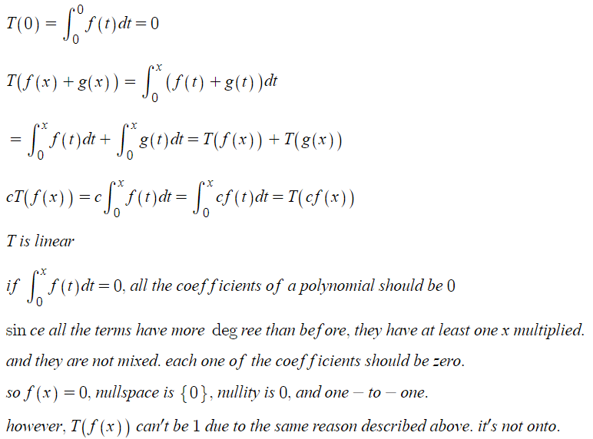

20.

let v1, v2 members of V1.

T(0)=0 so T(V1) has 0 as a member.

aT(v1)+T(v2)=T(av1+v2) so T(V1) is closed in addition and multiplication.

so T(V1) is a subspace of W.

let x1, x2 members of the given set {x∈V:T(x)∈W1}.

T(0)∈W1 so 0∈V so the set has 0 as a member.

since T(x1), T(x2) are members of W1 and W1 is a subspace,

aT(x1)+T(x2)=T(ax1+x2)∈W1 so ax1+x2 is a member of the set.

so the set is a subspace of V.

2.2

3.

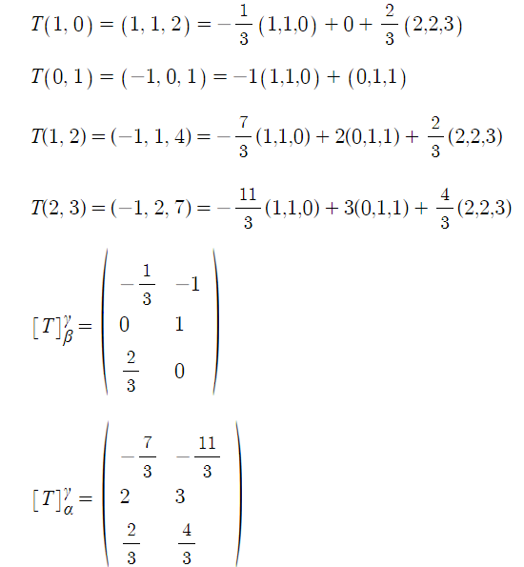

8.

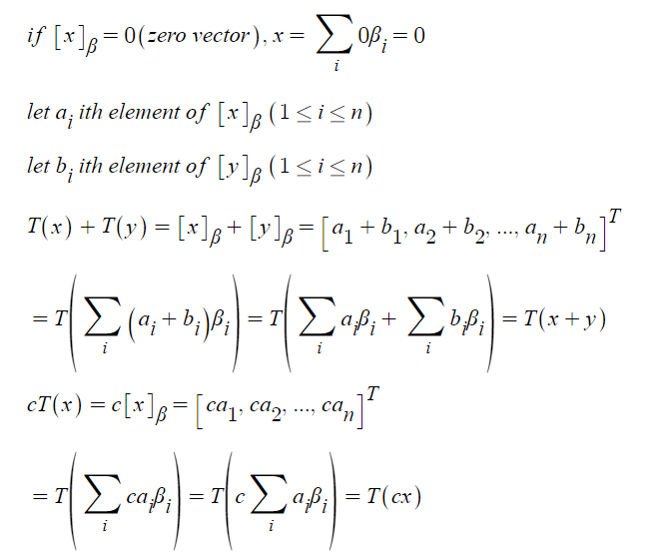

16.

let bases for the nullspace A={β1, β2, ..., βk}. there exists β={β1, β2, ..., βn} an extension from A and let this be the ordered bases for V. T(βi)=0 where 1≤i≤k. let γi=T(βi) (1≤i≤n). {γk+1, γk+2, ...,γn} is linearly independent as in the proof of dimension theorem. let γ={γk+1, γk+2, ...,γn} be the ordered bases for R(T). then the matrix representation of T in the ordered bases β and γ is a diagonal matrix D where dij=0 (i≠j), dii=0 (1≤i≤k), dii=1 (k+1≤i≤n)